Analysis
11/18/2019
The purpose of this document is to make use of the data stored within the FIDE data folder.
Before beginning, we need to import several packages that help run the code below.
library(tidyverse)
## -- Attaching packages ----------------------------------------------------------------------------------------------------------- tidyverse 1.2.1 --
## v ggplot2 3.2.1 v purrr 0.3.3
## v tibble 2.1.3 v dplyr 0.8.3
## v tidyr 1.0.0 v stringr 1.4.0
## v readr 1.3.1 v forcats 0.4.0
## Warning: package 'ggplot2' was built under R version 3.6.1
## Warning: package 'tibble' was built under R version 3.6.1
## Warning: package 'tidyr' was built under R version 3.6.1
## Warning: package 'purrr' was built under R version 3.6.1
## Warning: package 'dplyr' was built under R version 3.6.1
## -- Conflicts -------------------------------------------------------------------------------------------------------------- tidyverse_conflicts() --
## x dplyr::filter() masks stats::filter()
## x dplyr::lag() masks stats::lag()
library(data.table)
## Warning: package 'data.table' was built under R version 3.6.1
##
## Attaching package: 'data.table'
## The following objects are masked from 'package:dplyr':
##
## between, first, last
## The following object is masked from 'package:purrr':
##
## transpose
library(xts)
## Loading required package: zoo
##
## Attaching package: 'zoo'
## The following objects are masked from 'package:base':
##
## as.Date, as.Date.numeric
## Registered S3 method overwritten by 'xts':
## method from
## as.zoo.xts zoo
##
## Attaching package: 'xts'
## The following objects are masked from 'package:data.table':
##
## first, last
## The following objects are masked from 'package:dplyr':
##
## first, last
library(dygraphs)
## Warning: package 'dygraphs' was built under R version 3.6.1
tidyverse imports dplyr, tidyr and several other useful packages for data wrangling and manipulation.
data.table is used purely for speeding up imports.

Access the data
The data is stored in a path we have to manipulate to get to.
path = "~/GitHub/Chess_data/FIDE Data/Data NOV19/"
temp = list.files(path = path,
pattern = "\\.csv?")
head(temp)
## [1] "APR01.csv" "APR02.csv" "APR03.csv" "APR04.csv" "APR05.csv" "APR06.csv"

Create functions to rename datasets
Below, I define a few functions that help us rename the datasets eventually
num <- function(x) match(tolower(x), tolower(month.abb))
month <- function(x){return(substr(x, 1, 3))}
add_zero <- function(x){if (x <= 9){x = paste("0", x, sep = "")}; return(x)}

Get the month number of all of the files in the dataset
Below, I rename create the variables names when they are imported in memory.
temp%>%
sapply(month)%>%
sapply(num)%>%
sapply(add_zero)%>%
paste("20", substr(temp, 4, 5), "-", ., "-", "01", sep = "")-> month_num
head(month_num)
## [1] "2001-04-01" "2002-04-01" "2003-04-01" "2004-04-01" "2005-04-01"
## [6] "2006-04-01"
We can see that the datasets correspond to dates on which the is recorded.

Import a sample of datasets
Due to the data being quite large, your RAM may be used heavily. Because of this, I have chosen to randomly sample an n number of datasets. Please adjust n to length(month_num) if you want to wait for a long time for all of the data to process.
proper_temp <- paste(path, temp, sep = "")
n = length(month_num)
dataset_random = sample.int(length(month_num), n)
for(i in 1:length(proper_temp)) {
assign(month_num[i], fread(proper_temp[i], sep = "*", data.table = FALSE, strip.white = TRUE, blank.lines.skip = TRUE))
}
#Put datasets in list
FIDE <- mget(ls(pattern = "[0-9][0-9]-[0-9][0-9]"))
rm(list=setdiff(ls(), c("FIDE", "ptm")))
#Help rename columns in the data
vector_months <- c(month.abb, tolower(month.abb),toupper(month.abb))
string = ""
for (i in 1:length(vector_months)){
if (i == 1){string = vector_months[i]}
else if (i > 1) {string = paste(string, vector_months[i], sep = "|")}
}
string = paste(string, "RATING", sep = "|")
#Insert month column
for(i in 1:length(FIDE)){
colnames(FIDE[[i]])[grepl("Name|NAME|name", colnames(FIDE[[i]]))] <- "Name"
colnames(FIDE[[i]])[grepl("NUMBER", colnames(FIDE[[i]]))] <- "ID_Number"
colnames(FIDE[[i]])[grepl("Fed|FED|COUNTRY", colnames(FIDE[[i]]))] <- "Country"
colnames(FIDE[[i]])[grepl("Gms|GAMES|GM|Game|GAME", colnames(FIDE[[i]]))] <- "Games"
colnames(FIDE[[i]])[grepl("K", colnames(FIDE[[i]]))] <- "K_factor"
colnames(FIDE[[i]])[grepl("FLAG|Flag|flag", colnames(FIDE[[i]]))] <- "Activity"
colnames(FIDE[[i]])[colnames(FIDE[[i]]) %in% c("Wtit","wtit","WTIT", "WTit")] <- "Womens_Title"
colnames(FIDE[[i]])[colnames(FIDE[[i]]) %in% c("TITLE","Title","title","Tit")] <- "Title"
colnames(FIDE[[i]])[grepl(string, colnames(FIDE[[i]]))] <- "Rating"
colnames(FIDE[[i]])[grepl("Born|Age|age|BIRTHDAY|B-day|Bday", colnames(FIDE[[i]]))] <- "Age_Birthday"
colnames(FIDE[[i]])[grepl("SEX", colnames(FIDE[[i]]))] <- "Sex"
colnames(FIDE[[i]])[grepl("FOA", colnames(FIDE[[i]]))] <- "FIDE_Online_Arena"
colnames(FIDE[[i]])[grepl("OTit", colnames(FIDE[[i]]))] <- "Other_Titles"
FIDE[[i]] <- FIDE[[i]] %>%
mutate(Date = as.Date(names(FIDE)[i]),
Rating = as.numeric(Rating))
}
## Warning: NAs introduced by coercion
## Warning: NAs introduced by coercion
## Warning: NAs introduced by coercion
## Warning: NAs introduced by coercion
## Warning: NAs introduced by coercion
## Warning: NAs introduced by coercion
## Warning: NAs introduced by coercion
## Warning: NAs introduced by coercion
## Warning: NAs introduced by coercion
FIDE <- rbindlist(FIDE, fill = TRUE)%>%select(-V1)
# fwrite(FIDE, "FIDE.csv")
# FIDE <- fread("FIDE.csv", data.table = FALSE)
Now that we have the data in a more clean, usable format, it’s time we analyzed it.
tabled <- table(FIDE$Activity)%>%
data.frame()%>%
mutate(Var1 = as.character(Var1))
#
#
# summary <- FIDE%>%
# filter(Activity %in% tabled$Var1[1:4])%>%
# group_by(Country, Date)%>%
# summarise(Rating = mean(Rating, na.rm = T),
# Population = n())
Active_player <- FIDE%>%
filter(Activity == "")%>%
group_by(Date)%>%
summarise(total_count = n(),
avg_rating = mean(Rating),
sd_rating = sd(Rating))
ggplot(data = Active_player, aes(x = Date, y = total_count)) +
geom_line(color = "#FC4E07", size = 2)+
xlab("Year")+
ylab("# of active players")+
geom_segment(aes(x=as.Date("2004-06-01"), xend=as.Date("2008-06-01"), y=120000, yend=70000),
arrow = arrow(length = unit(.5, "cm")), size = 2)+
geom_segment(aes(x=as.Date("2004-06-01"), xend=as.Date("2002-02-01"), y=120000, yend=35000),
arrow = arrow(length = unit(.5, "cm")), size = 2)+
annotate("text", x = as.Date("2007-06-01"), y = 130000, label = "Corrupted data lead to lost rows (will be addressed in future scripts)", size = 5)+
# geom_smooth(se = FALSE)+
theme_bw()
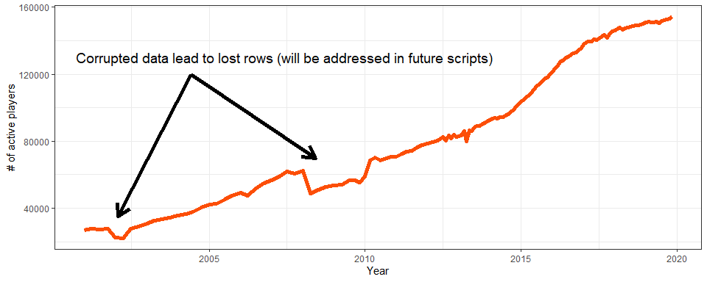
FIDE%>%
filter(Rating > 2830)%>%
.$Name%>%
unique() -> top_player
#Visualize the data
WC_caliber_players <- FIDE%>%
filter(Name %in% top_player, Activity == "")%>%
select(Name, Rating, Date)%>%
arrange(Name, Date)
dygraphed <- WC_caliber_players %>%
spread(key = Name, value = Rating)%>%
xts(.[,which(colnames(.)!= "Date")],order.by = .$Date)
dygraph(dygraphed, main = "Player's rating over Time") %>%
dyOptions(drawPoints = TRUE, pointSize = 2, axisLineWidth = 4) %>%
dyAxis("y", label = "Rating", valueRange = c(1900, 3200))%>%
dyRangeSelector()%>%
dyLegend(width = 400)
# data <- fread("SEP19.csv", sep = "*", data.table = FALSE)
#
# library(ggplot2)
# data%>%
# mutate(Rating = as.numeric(NOV19))%>%
# filter(Flag == "wi")%>%
# na.omit()%>%
# ggplot(aes_string(x="Rating"))+
# geom_density(size=2, alpha=.4)+
# geom_histogram(aes(y = ..density..), bins = 50, col= "red")+
# labs(title="Histogram overlayed with Density curve") +
# labs(x="Rating", y="Percentage of players in population")

